Lesson 6 Content
Lesson 6: Working with Conditional Structures. Properties: Transparency, CanCollide, Enabled (2 hours)
Welcome to the sixth lesson of our Roblox course. Today, our focus will be on learning about conditional statements and working with such key object properties as Transparency, CanCollide, and Enabled.
Conditional statements are an integral part of any programming language. Understanding their mechanics and application in Roblox will help you create interactive and engaging scenarios for players. In addition, the ability to manipulate object properties will allow you to achieve the desired visual and physical effects in your game.

In this lesson, we have prepared detailed instructions and practical examples for you. You will learn how to set up various conditions for objects, as well as how to programmatically control their properties.

1. Introduction and Homework Review (10 minutes)
Greetings, attendance check, and discussion of homework. Give an opportunity for those who wish to present their projects.

2. Working with the Transparency and CanCollide Properties (30 minutes)
We will continue working with the same project that we prepared in the last lesson.

3.1 Adding a Bridge (5 minutes)
We will add a bridge that will connect our islands.
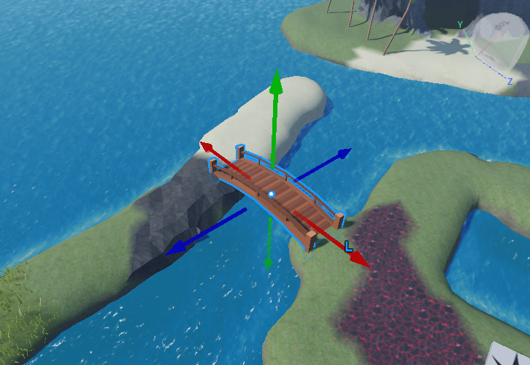
As a model, a Medieval Wooden Bridge will be suitable.
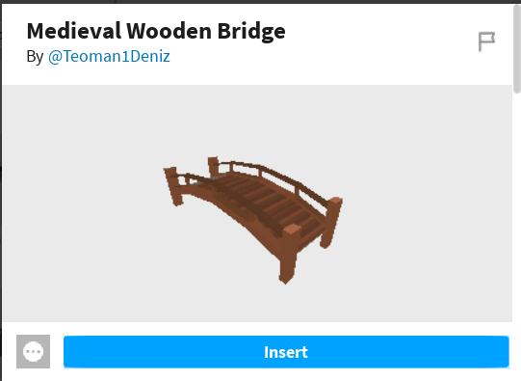

3.2 Working with the Transparency Property (5 minutes)
We will run the game. We will show the children the Transparency property and how it affects the object.
Transparency is a property of an object in Roblox that determines its transparency. The value of this property ranges from 0 to 1, where:
- 0 means full opacity, i.e., the object is completely visible.
- 1 means full transparency, i.e., the object is absolutely invisible.
With this property, you can make objects fully or partially transparent, creating various visual effects. For example, this can be useful when creating glass surfaces, ghostly objects, or bodies of water.
You can make an object completely invisible, but this does not remove it from the game. In this case, we will be able to walk on the invisible bridge.
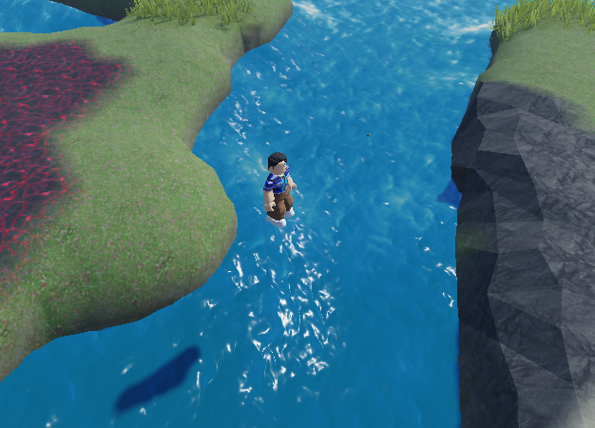

3.3 Working with the CanCollide Property (5 minutes)
Let's return the bridge to visibility.
We will show the children the CanCollide property and how it affects the object.
CanCollide is a property of an object in Roblox that determines whether the object can collide with other objects. This boolean property has two possible values:
- true: The object will collide with other objects, preventing them from passing through each other. This is useful for creating obstacles, walls, floors, and other objects that should block the movement of players or objects.
- false: The object will not collide with other objects, allowing them to pass through it. This can be useful for creating objects such as decorations that are visually present but do not interact with players or other objects in the game.
We will set this property to false (remove the checkmark) and show what happens.
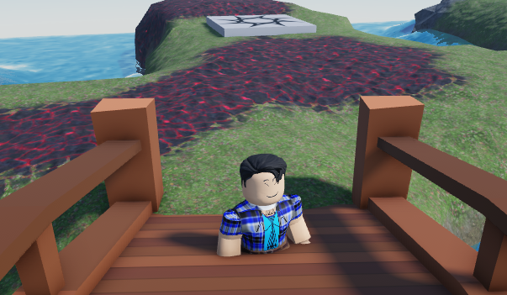

3.4 Experiments with Properties (5 minutes)
Allow the children to experiment with different values of these properties. The final version of our bridge should be a ghostly bridge that does not respond to touches and collisions. 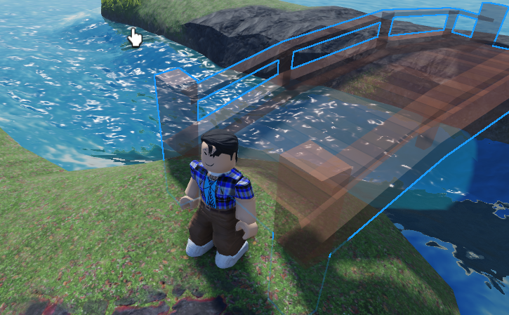

3.5 Working with Transparency and CanCollide Properties from Code (15 minutes)

Step 1: Creating the Main Script

First, let's create a new script in the Workspace and name it "main". In this script, we will work with two key properties of the object: Transparency and CanCollide.
local bridge = game.Workspace.bridge
bridge.Transparency = 0
bridge.CanCollide = true
Step 2: Working with Boolean Values
In the code, we used the values true and false. These are special types of data called boolean values. In the Roblox interface, for example, for the CanCollide property, you set it using a checkbox. However, when we work with code, we use true to denote "enabled" and false for "disabled".
Think of them like a light switch: true is when the light is on, and false is when it's off.
Step 3: Converting Code into a Function
To make our code more universal and allow its use in different parts of the game, let's convert it into a function. We will make the function global. Remind the children what global functions and variables are; this information is available in the materials of Lesson 3.

_G.showBridge = function()
local bridge = game.Workspace.bridge
bridge.Transparency = 0
bridge.CanCollide = true
end

Step 4: Adding an Interactive Button to Show the Bridge
- Creating the Button: First, add an object to the game space that will serve as a button. It can be any object that fits the theme of your game - for example, a decorative stone or a magical crystal. Let's name the object bt1.
Objects:
When you are looking for objects to add to your game in Roblox Studio, it is recommended to select the "Meshes" category in the filter. This will ensure that you get simple shapes that are perfect for getting started:

Ease of Use: Meshes are three-dimensional objects that are easy to work with in the editor.
Customization of Appearance: You can easily change the color and material of these shapes to match your design.
Touch Response: Meshes correctly respond to various interactive actions, such as touch, making them ideal for creating interactive elements of the game.
What are "Meshes"?
The word "Meshes" translates from English as "nets". In the context of computer graphics and game development, these are three-dimensional models made up of vertices, edges, and faces that together form the surface of an object. Meshes are widely used to create various objects in games, from simple shapes to complex characters and scenarios.
- Adding a Script to the Button: Insert a new script into the object you've created
- Code for Touch: In this script, create an event handler that will respond to the player's touch. It might look something like this:

local button = game.Workspace.bt1
function touch()
_G.showBridge()
end
button.Touched:Connect(touch)

3. Effects and the Enabled Property

3.1 Working with the Enabled Property (5 minutes)
To add interactivity to your crystal and show that it has been activated, we can use an effect, such as ParticleEmitter.
A ParticleEmitter allows for the creation of various particles that can simulate effects like smoke, fire, sparks, and many others. It's an excellent way to visualize activation or other interactions with objects in your game.
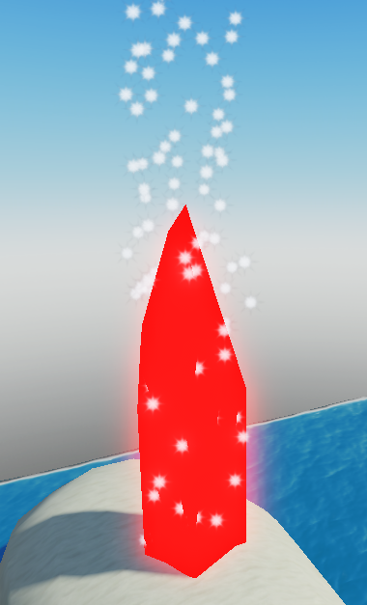
One of the key properties of ParticleEmitter is the Enabled property. This boolean property determines whether the particle effect is currently active. If Enabled is set to true, particles will be generated. If false, no particles will appear.

Working with the Enabled Property from Code (5 minutes)
Action Plan:
- Setting up the Effect: Add a ParticleEmitter component to the crystal and configure it to match our visual preferences. This may involve changing the shape, color, speed, and other particle parameters.
- Initial State: After setting up the effect, we'll turn it off by setting the Enabled property to false. This way, when the game starts, particles won't generate until the player interacts with the crystal.
- Activation via Code: We'll modify our script so that when the crystal is touched, the ParticleEmitter effect is turned on. This will be our visual feedback to the player, signaling that the crystal has been activated.

local button = game.Workspace.bt1
function touch()
button.ParticleEmitter.Enabled = true
_G.showBridge()
end
button.Touched:Connect(touch)

4. Break (10 minutes)

5. Conditions. The if Statement. Theory. (15 minutes)

5.1 Conditions
Let's consider a real-life situation. In the morning, before going outside, you look out the window to check if it's raining. If it is raining, you take an umbrella. This is a condition: "if it rains, then umbrella".
In programming, we constantly encounter such "if-then" situations. It allows us to give the computer instructions for different scenarios. For example, "if the user clicks the button, then open a new window".
Such conditions are very important because they allow us to create smarter and more adaptive programs. Without them, our code would be very basic and perform the same way every time, regardless of what's happening around. But thanks to conditions, we can create more flexible and interactive programs that respond to different situations and data.
Examples:
- When deciding whether to take an umbrella, you ask yourself: "Is it raining?". If yes, then you take an umbrella.
- In a math class, the teacher says: "If you have 5 apples and you give away 2, you will have 3 left".
- In a computer game: if the character presses a button, then a door opens.

5.2 True and False
Remember when your parents asked you if you brushed your teeth before bedtime? And you answered "yes" or "no"? In programming, such an answer is called "true" or "false". These are the fundamental responses that a computer can give to certain questions or conditions.
Consider a simple real-life situation: if it is raining, you decide to take an umbrella. What condition are we checking here? "Is it raining?". If this condition is true, then you take an umbrella. If it is false, then the umbrella stays home. Thus, the question "Is it raining?" can have two answers: "yes" (true) or "no" (false). Therefore, in programming and in real life, we often encounter situations where we need to check whether something is true or not.
Examples:
- The statement "The sun is hot" is true.
- To say "Snow is hot" is false.

5.3 The if-then Conditional Operator
Have you ever been told, "If you clean your room, then you'll get a treat"? That's a conditional statement. In programming, such a statement is created using the "if-then" conditional operator.
Let's consider a real-life scenario: suppose you have a piggy bank and you want to buy a toy if you have enough money. Thus, your action (buying the toy) depends on the condition (having enough money). If the condition is true (yes, there's enough money), then you buy the toy. If the condition is false (no, there isn't enough money), then you continue to save.
local money = 85

if money > 80 then
print("Success!")
end

5.4 The if-then-else Conditional Operator
But what if we have another action to take if the main condition isn't met? For example: "If it rains tomorrow, I will take an umbrella; otherwise, I will take sunglasses." Here we have two possible actions depending on whether it's raining or not.
In programming, we have "if-then-else" for such situations. If the condition is true (yes, it will rain tomorrow), you take an umbrella. If the condition is false (no, it will not rain tomorrow), you take sunglasses. It's like in games where you have a choice: go left or right. Depending on your choice, the story of the game changes.
Examples:
- If it's raining outside, then take an umbrella; otherwise, take sunglasses.
- If the store is open, then buy milk; otherwise, go back home.
- In a game: if the character has a key, then they can open the door; otherwise, the door remains closed.
local weather = "sunny"

if weather == "rainy" then
print("Возьмите зонтик!")
else
print("Приятного дня на улице!")
end

5.5 Logical AND / Logical OR
Sometimes one condition isn't enough. Often we need to consider multiple conditions simultaneously. This is where the logical operators "and" and "or" help us.
Let's imagine it's raining today and you're deciding how to get to work. If it's raining today AND you're walking, then you take an umbrella. This means that both conditions ("it's raining" and "I'm walking") must be met at the same time for you to take an umbrella. If at least one of the conditions is false (for example, you're driving), then you don't need an umbrella.
Now let's consider another example: you're deciding whether you need to bring a bag. You take a bag if you're going to the store OR you have a lot of things with you. Here, it's sufficient that at least one condition is met ("I'm going to the store" or "I have a lot of things"). If at least one of the conditions is true, you take the bag.
As you can see, with the logical operators "and" and "or," you can easily combine different conditions and make more complex decisions depending on the situation.
Examples:
- If it's cold outside and it's raining, you will wear a warm jacket and take an umbrella.
- If you have a coin or a bill in your pocket, you can buy ice cream.
- In a game: if you have a key OR a code, you can open the door.
Logical 'and':
local isRainy = true
local hasUmbrella = false

if isRainy and hasUmbrella then
print("It's rainy, and you have an umbrella. You can go outside without getting wet.")
else
print("You might get wet because either it's not rainy or you don't have an umbrella.")
end
Logical 'or':
local isWeekend = true
local hasFreeTime = false

if isWeekend or hasFreeTime then
print("You can relax because it's either the weekend or you have some free time.")
else
print("It seems you can't relax because it's not the weekend and you don't have free time.")
end
Mixed use of 'and' and 'or':
local isHoliday = false
local isWeekend = true
local hasFreeTime = true

if (isHoliday or isWeekend) and hasFreeTime then
print("You can go on a trip because it's a holiday or weekend, and you have free time.")
else
print("You can't go on a trip because it's neither a holiday nor weekend, or you don't have free time.")
end

5.6 The Difference Between "=" and "=="
Imagine you have a box, and you want to put an apple into it. When you do this, you say: "Box, now you have an apple inside!". In programming, when we want to "place" or "assign" something somewhere, we use the "=" sign. This is called the assignment operator. For example, when we say "a = 5", it means that we are "placing" the value 5 into the variable a.

Now imagine you have two boxes, and you want to know if they contain the same thing. To do this, you would open them and compare. If the contents are the same, you'd say: "Yes, they are the same." In programming, to compare two things, we use "==" - this is the comparison operator. For example, "a == 5" asks: "Is the value of the variable a equal to 5?"

Thus, the main difference between "=" and "==" is that "=" says "be this", while "==" asks "are you this?". Don't confuse them! If you use "=" when you actually want to use "==", it can lead to errors in your code. Remember, "=" sets a value, and "==" checks for equality.

6. Practice (35 minutes)

We will analyze a case where 2 buttons are needed to open a passage.
How our code algorithm looks now:
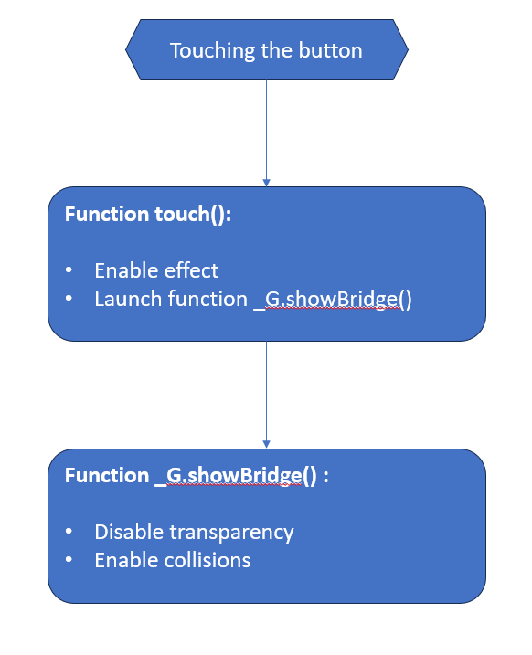
Let's now consider the algorithm for two buttons:
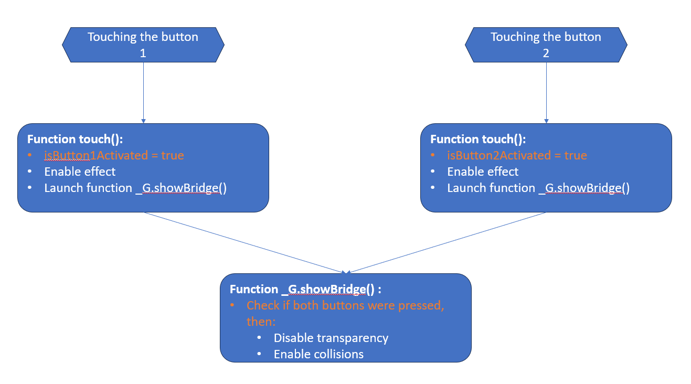
The new steps that need to be added to the code are highlighted in orange.
These diagrams are available in the Algo.ppt file in the folder with the current file. They can be used for discussion.
  - First, we'll add 2 global variables to store the states of the buttons. We will add 2 lines to the main script.
_G.isButton1Activated = false
_G.isButton2Activated = false

And we will set each variable to the initial value of false. This will mean that the button has not yet been activated.
  - Add a second button following the same procedure we used to add the first button at the beginning of the lesson, or simply copy the first button and make the appropriate changes in the code.
  - Change the touch functions for the buttons:
For button1:
local button = game.Workspace.bt1
function touch()
button.ParticleEmitter.Enabled = true
_G.isButton1Activated = true;
_G.showBridge()
end
button.Touched:Connect(touch)
For button2:
local button = game.Workspace.bt2
function touch()
button.ParticleEmitter.Enabled = true
_G.isButton2Activated = true;
_G.showBridge()
end
button.Touched:Connect(touch)
- Add a check in the function _G.showBridge() so that the bridge appears only if both buttons are activated.
_G.showBridge = function ()
if _G.isButton1Activated and _G.isButton2Activated then
b.Transparency = 0
b.CanCollide = true
end
end

Our example code is ready.
Remember that the touch event occurs when any object is touched, including the landscape. To achieve the expected behavior, our crystal-buttons should be positioned above the ground.

If there is time, we can consider a case where the bridge becomes active upon the activation of any button. To do this, simply change the condition:
_G.showBridge = function ()
if _G.isButton1Activated or _G.isButton2Activated then
b.Transparency = 0
b.CanCollide = true
end
end

7. Homework (5 minutes)
For your homework, the following action plan is proposed:
- Using the landscape editing tools in Roblox, create a new area on your map. This area can be something like a new island or an extension of the existing territory.
- Add a bridge to this new area. Use the object properties to make it invisible (Transparency = 1) and incapable of collisions (CanCollide = false), so that characters cannot see or collide with it.
- Place two items in the new area that will act as keys or collectible objects to activate the bridge.
- Organize the script logic so that the bridge becomes visible and collision-capable only when both items are collected. Use global variables or another method to track the item collection state.
- Write a script for each of the items that will respond to the player's touch (Touched event). After being touched, the item should disappear, and its collection state should be accounted for in the overall logic of the bridge's appearance.
The implementation of this homework assignment can be seen in the lesson project.
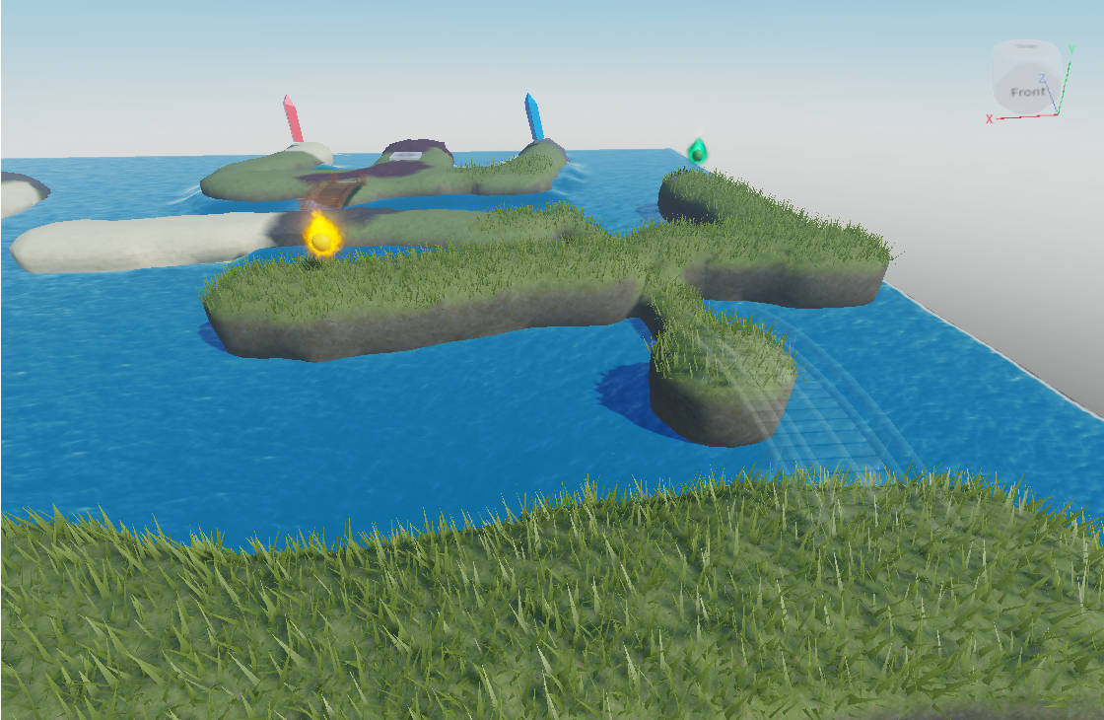

8. Feedback (5 minutes)
At the end of the lesson and upon completing independent tasks, it's important to gather feedback from the students. This helps to understand not only what was most useful and interesting for them but also to identify areas that may need improvement or further explanation.
Idea for conducting a feedback session:
Positive Point: Ask the children to take turns sharing what they liked most during the lesson. This could be a specific tool, effect, or just the general teaching approach.
Area for Improvement: Also, invite students to express what they did not like or what they think needs to be improved. This could be the complexity of the material, pace of teaching, or some technical aspects.
Summary: After everyone has spoken, draw conclusions. Note the general trends in the feedback and discuss what changes or improvements could be introduced in future lessons.
The feedback session is a valuable tool for the teacher, as it provides specific information about how the lesson was perceived by the students. This can also be a motivating factor for the children, as they see that their opinions are taken into account.

